**Digital Signal Processing Fundamentals [5ESC0]**

**Lab 5ESC4**

**‘Answer form’**

***Assignment 18 to 26***

**Group number:** 13

**Names with ID:** Martyn van Dijke | 0887668

Marijn Rombouts | 0887946

**Date:** 3 November 2016

**Assignment 18: Mean and variance**

1. Expression for the mean and variance:

$$μ_{x}=E\{ \frac{1}{N}⋅\sum_{n=0}^{N-1}{x\left[n\right] \} , σ_{x}^{2}=E \{\frac{1}{N}\sum_{n=0}^{N-1}{{\left(x\left[n\right]- μ_{x}\right)}^{2}\}= \frac{1}{N} }\sum_{n=0}^{N-1}{x^{2}\left[n\right] - μ_{x}^{2} }}$$

$$μ_{uN}\left[n\right]=\frac{1}{N}\sum_{i=1}^{N}{x_{i}\left[n\right] , with x_{i}\left[n\right] }=μ_{i}= \frac{1}{N}⋅\sum_{n=0}^{N-1}{x_{i}\left[n\right]} =0$$

$$μ_{uN}\left[n\right]=\frac{1}{N_{i}}\sum_{i=1}^{N_{i}}{μ_{i} }= \frac{1}{N_{i}}\sum_{i=1}^{N_{i}}{\left(\frac{1}{N}⋅\sum_{n=0}^{N-1}{x_{i}\left[n\right]}\right) }=0$$

$$μ_{uN}\left[n\right]=0$$

$$σ_{uN}^{2}=\frac{1}{N_{i}}\sum_{i=1}^{N_{i}}{σ_{i}^{2} , with σ_{i}^{2}}=\frac{1}{N}⋅\sum_{n=0}^{N-1}{{E \{x}_{i}^{2}\left[n\right]\} - μ_{i }^{2}}$$

$$σ_{uN}^{2}= \frac{1}{N_{i}}\sum_{i=1}^{N_{i}}{\left(\frac{1}{N}⋅\sum_{n=0}^{N-1}{E\{ x_{i}^{2}\left[n\right] \}-0}\right) }=\frac{1}{N}⋅\sum_{i=1}^{N_{i}}{\left(\frac{1}{N}⋅\sum_{n=0}^{N-1}{E\{ x_{i}^{2}\left[n\right] \}}\right) }$$

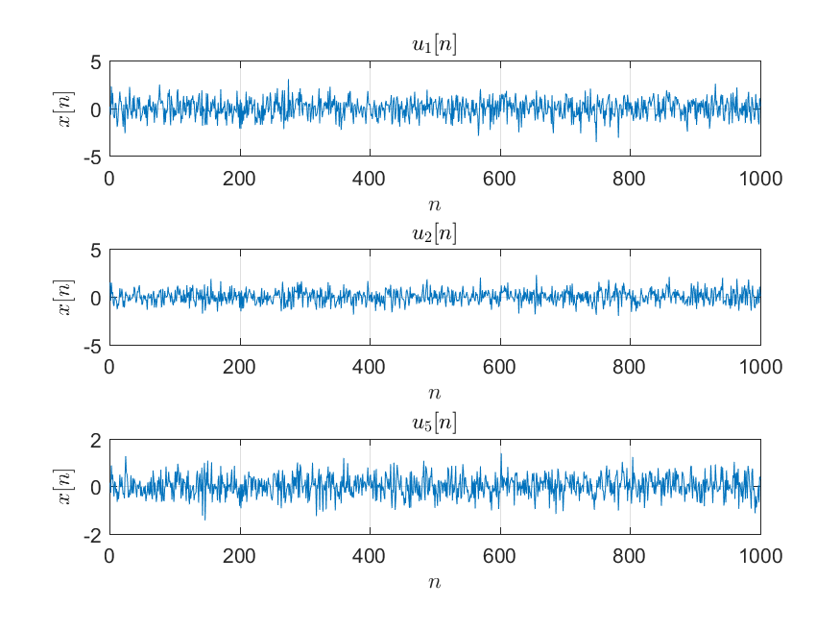

**Figure 4: u[n] for different N**

1. Statement about the mean and variance of a random variable which consists of the normalized sum of N IID random variables:

The mean and random variable of a normalized sum of N IID random variables is the same as the mean and variance of a random IID variable, if and only if the random N IID variables are made with the same mean and variance.  
This is due the fact that the mean and variance of a N IID sum of random variables is nothing more than a normalized sum of N random IID variables.

**Assignment 19: Mathematical expressions for variance and correlation coefficients**

1. Expression and plot of variance:

$$Y_{N}=\frac{x_{1}\left[n\right]+\left(N-1\right)x_{2}\left[n\right]}{N}{, σ}_{YN}^{2}=E\{ \frac{1}{N}⋅\sum_{n=0}^{N-1}{Y_{N}^{2}\left[n\right]-μ_{N}^{2} \}}$$

$$σ_{YN}^{2}=E \left\{\frac{1}{N}⋅ \sum_{n=0}^{N-1}{{\left( \frac{x_{1}\left[n\right]+\left(N-1\right)x_{2}\left[n\right]}{N}\right)}^{2}}-μ_{YN}^{2} \right\}$$

$$with μ_{YN}= E\left\{ \frac{1}{N}⋅\sum_{n=0}^{N-1}{\frac{x_{1}\left[n\right]+\left(N-1\right)x_{2}\left[n\right]}{N}} \right\}=E\left\{\frac{ μ_{x1}+\left(N-1\right)⋅μ_{x2}}{N}\right\}=0$$

$$σ_{uN}^{2}= E \left\{\frac{1}{N_{i}}⋅ \sum_{n_{i}=0}^{N_{i}-1}{\frac{1}{N}⋅\sum_{n=0}^{N-1}{\frac{x_{1}\left[n\right]+\left(N-1\right)x_{2}\left[n\right]}{N}}}\right\}-{\left(\frac{ μ_{x1}+\left(N-1\right)⋅μ_{x2}}{N}\right)}^{2} \\ {with μ}_{x1}= μ_{x2}=0 \& σ_{i}^{2}= σ_{x}^{2}=1$$

$$σ_{uN}^{2}= E \left\{\frac{1}{N}⋅ \sum_{n=0}^{N-1}{σ_{YN}^{2}}\right\}= E \left\{\frac{1}{N}⋅ \sum_{n=0}^{N-1}{1}\right\}=1$$

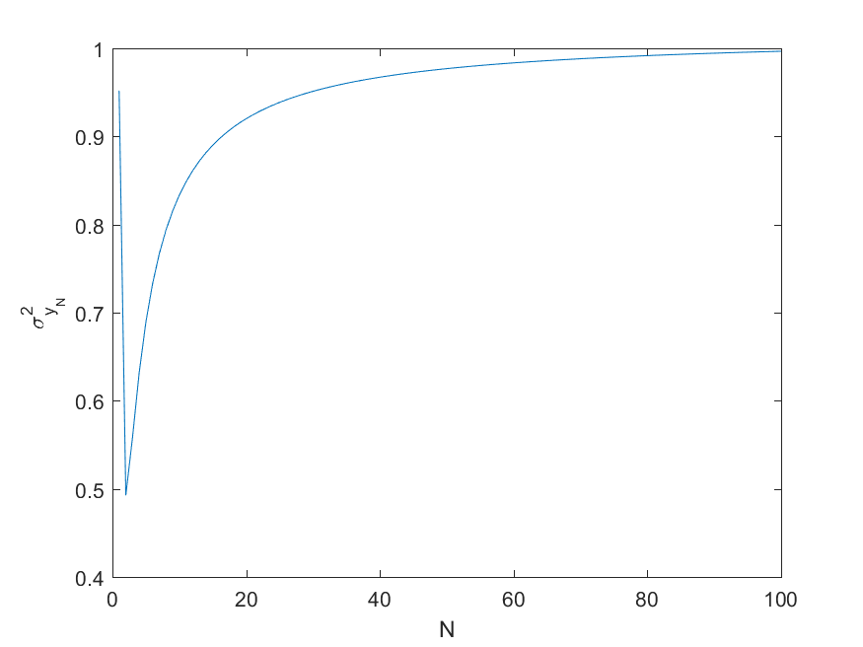

**Figure 1: Plot of variance as a function of N**

1. Expression and plot of normalized cross correlation coefficient:

$$ρ_{x2,YN}\left[0\right]=\frac{ E\left\{\left(x_{2}\left[n\right]- μ_{x}\right)⋅\left(y_{N}\left[n\right]- μ_{yN}\right)\right\}}{σ_{x2}⋅σ_{yN}}=r_{xy}\left[n,n\right]- μ_{x}\left[n\right]⋅μ_{y}^{*}[n] \\ {with μ}_{x}= μ_{y}=0$$

$$r_{xy}\left[n,n\right]=E\left\{ x\left[n\right]⋅y^{*}\left[n\right]\right\}$$

$$ρ_{x2,YN}\left[0\right]=r_{xy}\left[n,n\right]-0⋅0= r_{xy}\left[n,n\right] \\ ρ_{x2,YN}\left[0\right]=E\left\{ x\left[n\right]⋅y^{*}\left[n\right]\right\}$$

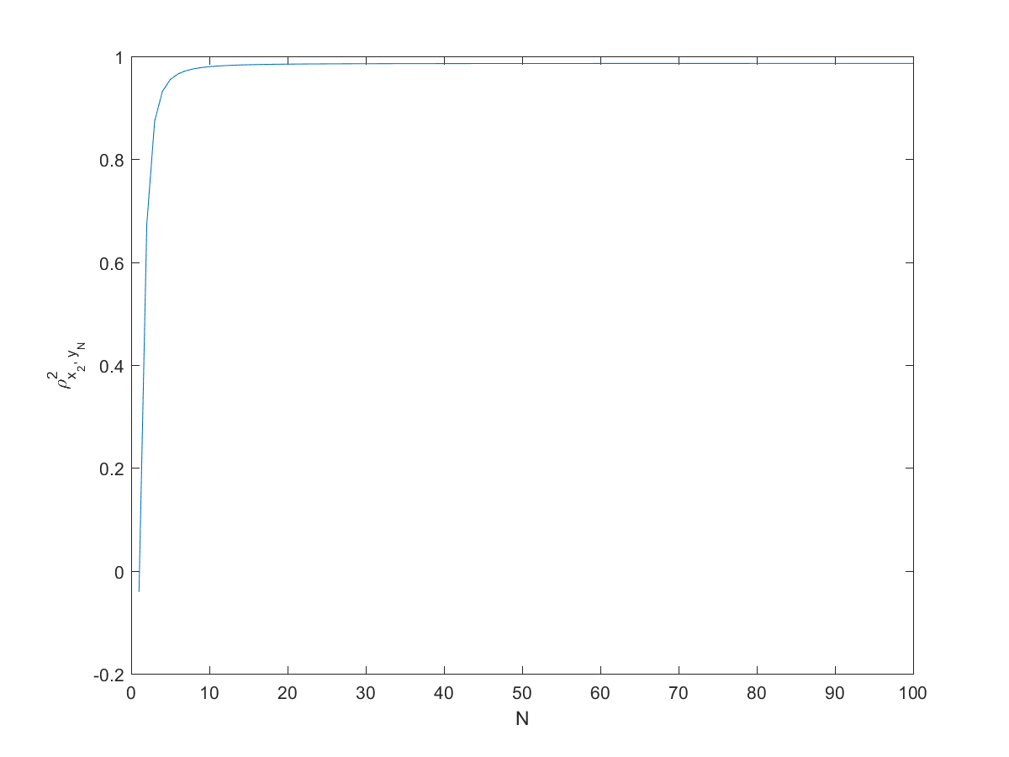

**Figure 2: Plot of normalized cross correlation coefficient as a function of N**

**Assignment 20: Scatter plots and empirically evaluate correlation coefficient**

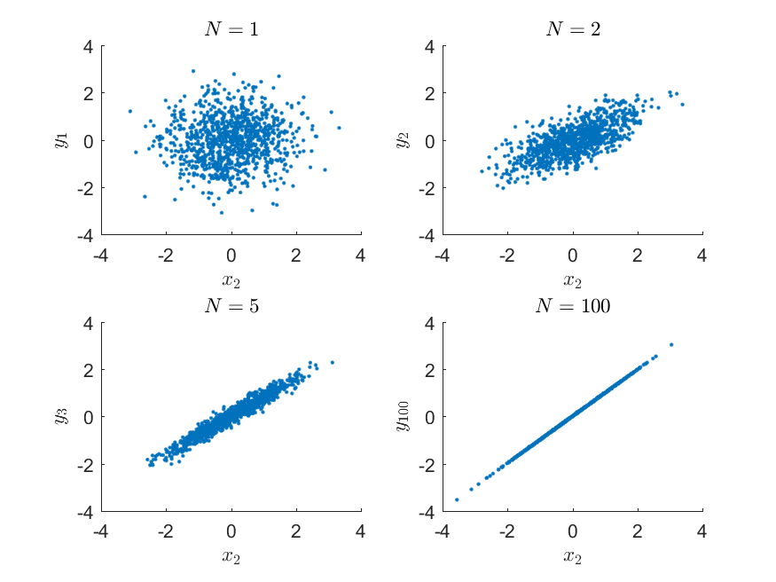

**Figure 3: Scatter plot of ordered pairs of samples**

1. Comparison of numerical estimates and theoretical results:

$$\begin{matrix}{\hat{ρ}}_{x2,Y1} \\ {\hat{ρ}}_{x2,Y2} \\ \begin{matrix}{\hat{ρ}}_{x2,Y5} \\ {\hat{ρ}}_{x2,Y100}\end{matrix}\end{matrix}= \begin{matrix}0.0440 \\ 0.4380 \\ \begin{matrix}0.8520 \\ 0.9980\end{matrix}\end{matrix}$$ From figure 3, it can be deduced that the estimate of the normalized cross function is within reasonable difference between the computed values and the theoretical results as shown in figure 3.   
From this it can be concluded that the numerical estimate holds.

1. Explain how the scatter plots are related to the normalized cross correlation coefficient:

The scatter plot is related to the normalized cross function in the manner that the scatter plot is more compressed, when the cross-correlation coefficient is higher.   
In other words, the scatter plot gives a graphically representation of the normalized cross correlation coefficient, where a higher cross correlation coefficient represents a more cluttered (“line like”) graph.

**Assignment 21: Correlation function and power spectral density (PSD) function**

1. Expression for theoretical correlation:

$$r_{y}\left[n\right]=E\left\{y\left[n\right]y\left[n-l\right]\right\}=E\left\{\left(\frac{1}{3}x\left[n\right]+\frac{1}{3}x\left[n-1\right]+\frac{1}{3}x\left[n-2\right]\right)\left(\frac{1}{3}x\left[n-l\right]+\frac{1}{3}x\left[n-l-1\right]+\frac{1}{3}x\left[n-l-2\right]\right)\right\}$$

$$r_{y}\left[n\right]=\frac{1}{9}\left\{E\left(x\left[n\right]x\left[n-l\right]\right)+E\left(x\left[n\right]x\left[n-l-1\right]\right)+E\left(x\left[n\right]x\left[n-l-2\right]\right)+E\left(x\left[n-1\right]x\left[n-l\right]\right)+E\left(x\left[n-1\right]x\left[n-l-1\right]\right)+E\left(x\left[n-1\right]x\left[n-l-2\right]\right)+ E\left(x\left[n-2\right]x\left[n-l\right]\right)+E\left(x\left[n-2\right]x\left[n-l-1\right]\right)+E\left(x\left[n-2\right]x\left[n-l-2\right]\right)\right\}$$

In which we can simplify some things:

$$r_{y}\left[n\right]=\frac{1}{9}\left(3r_{x}\left[l\right]+2r_{x}\left[l-1\right]+2r_{x}\left[l+1\right]+r_{x}\left[l-2\right]+r_{x}\left[l+2\right]\right)$$

Knowing that $r_{x}\left[n\right]=σ_{x}^{2}⋅δ[l]$, we can rewrite $r_{y}\left[l\right]$ to:

$$r_{y}\left[l\right]=\frac{1}{3}δ\left[l\right]+\frac{2}{9}δ\left[l-1\right]+\frac{2}{9}δ\left[l+1\right]+\frac{1}{9}δ\left[l-2\right]+\frac{1}{9}δ[l+2]$$

1. Derivations for theoretical PSD (two different ways):

Using FTD:

$$P_{y}\left(e^{jθ}\right)=\sum_{l=-∞}^{∞}{r_{y}\left[l\right]e^{-jθl}}=\frac{1}{3}+\frac{2}{9}e^{-jθ}+\frac{2}{9}e^{jθ}+\frac{1}{9}e^{-j2θ}+\frac{1}{9}e^{j2θ}=\frac{1}{3}+\frac{4}{9}\cos\left(θ\right)+\frac{2}{9}cos⁡(2θ)$$

Using $P_{y}\left(e^{jθ}\right)=P_{x}\left(e^{jθ}\right)⋅{\left|H\left(e^{jθ}\right)\right|}^{2}$

We know that $P_{x}\left(e^{jθ}\right)=σ_{x}^{2}=1$ and ${\left|H\left(e^{jθ}\right)\right|}^{2}=H\left(e^{jθ}\right)⋅H{\left(e^{jθ}\right)}^{*}$

Having $h[n]$, $H\left(e^{jθ}\right)$ can be determined as: $H\left(e^{jθ}\right)=\frac{1}{3}\left(1+e^{-jθ}+e^{-j2θ}\right)$

Therefore:

$$P_{y}\left(e^{jθ}\right)=\frac{1}{9}\left(1+e^{-jθ}+e^{-j2θ}\right)\left(1+e^{jθ}+e^{j2θ}\right)=\frac{1}{9}\left(3+2e^{jθ}+2e^{-jθ}+e^{j2θ}+e^{-j2θ}\right)=\frac{1}{3}+\frac{4}{9}\cos\left(θ\right)+\frac{2}{9}\cos\left(2θ\right)$$

**Assignment 22: Scatter plots**

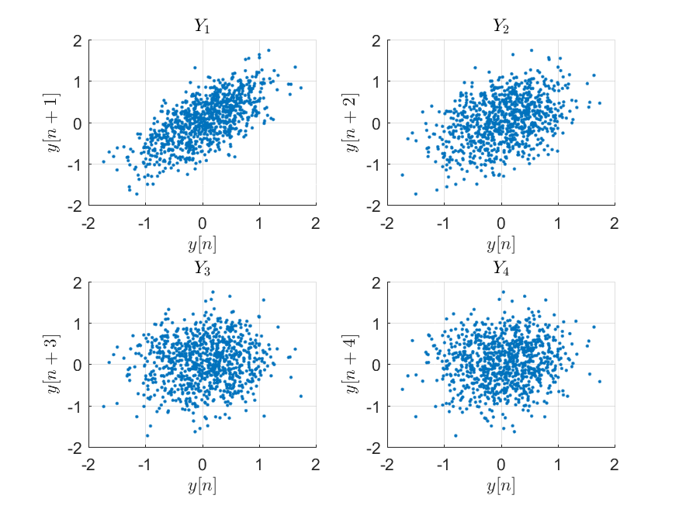

**Figure 5: Scatter plots**

What can you deduce about the random process y[n] from these scatter plots?

That a higher N results in a more stochastic process where the correlation efficient is lower than the previous N sample.  
This is due the fact that the y[n] is a 3 point averaging filter, in this way $Y_{1}, Y_{2}$ get a correlation that is higher than a normal random correlation since $Y_{1}, Y_{2}$ always contain parts of the $y\left[n\right]$ signal. With $Y_{3}$ this correlation is at its normal auto correlation value since it is now correlated with its one sample every 3 samples, and for $Y_{4}$ the signal is correlated with samples it does not contribute to therefore resulting in a lower correlation coefficient. $$y\left[n\right]=\frac{1}{3}⋅\left( x\left[n\right]+x\left[n-1\right]+x\left[n-2\right]\right)$$ 
In other words a higher N means a lower cross correlation coefficient, this is due the fact the filter is a 3 point average and that not every $y\left[n\right]$ sample contributes to $Y_{2 }, Y_{3} , Y_{4}$

**Assignment 23: Empirical correlation and PSD function**

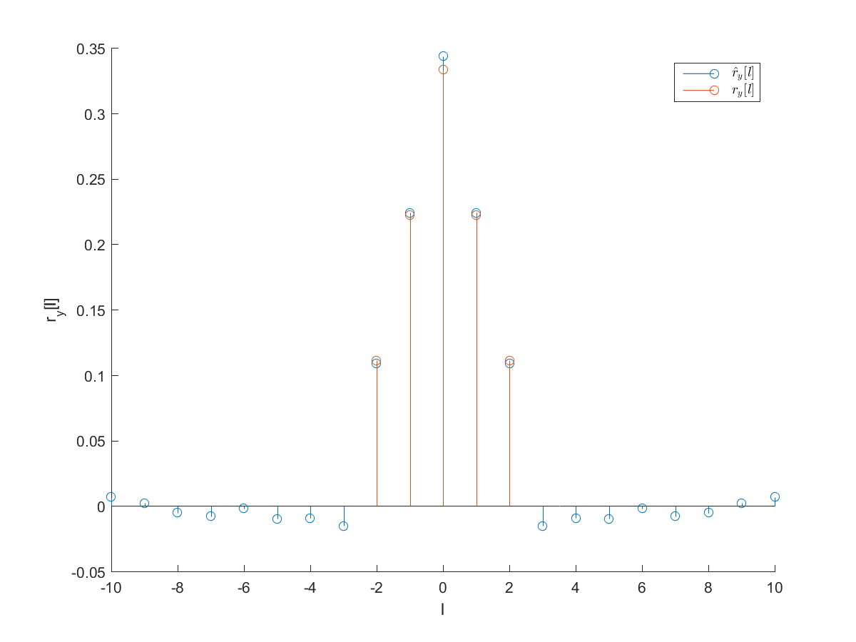

**Figure 6: Theoretical and estimated autocorrelation values**

1. For what value of lag l do the theoretical and estimated autocorrelation reach their maximum values?

The maximal autocorrelation is achieved at $l = 0$, when each sample is correlated with itself, which is approximately a third (which follows from the used filter).

1. Procedure for obtaining the PSD from the estimated values of the autocorrelation:

Using the FTD method, the PSD can be estimated. In Matlab this translates to:

P = fftshift(abs(fft(ry, 100)));

Where the PSD is the discrete Fourier transform (or fast Fourier transform in Matlab) with a higher resolution.

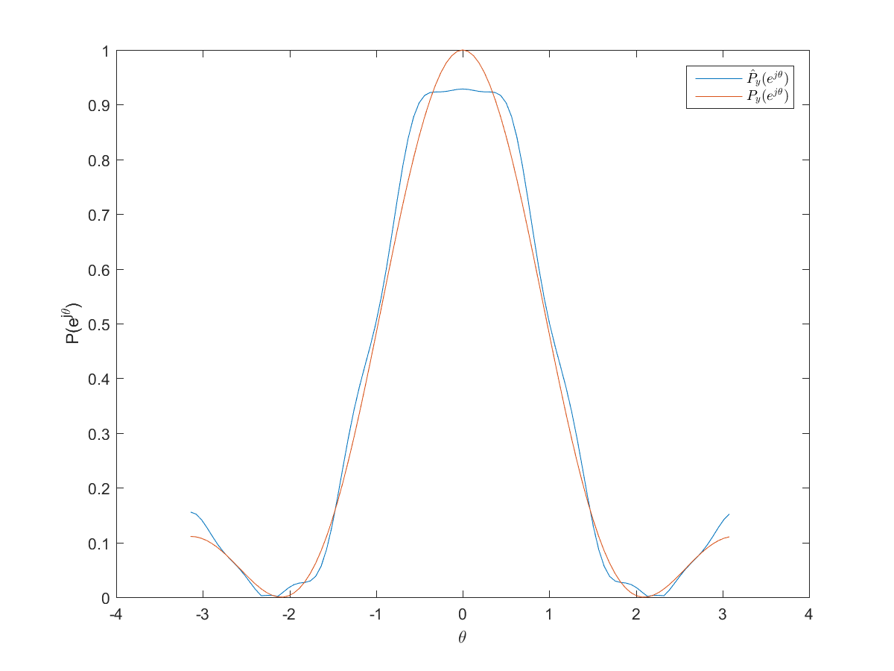

**Figure 7: Theoretical and estimated PSD**

1. Give a short reasoning of possible differences between the theoretical and estimated values of the PSD:

The estimated PSD is based on a discrete Fourier transform of the autocorrelation function $r_{y}[l]$, this approach is in theory accurate when the transform is executed analytically. Estimates are always executed numerically, and in a limited resolution. When the autocorrelation function has a limited resolution, the estimated PSD will also show inaccuracies, just like in the figure.

**Assignment 24: Expression for cross-correlation**

1. Short derivation for rxy[l]:
$${E\{x[n]\}= μ}_{x}= E\{ \frac{1}{N}⋅\sum_{n=0}^{N-1}{x\left[n\right] \} }$$

$$r_{x}\left[l\right]=\frac{1}{N}⋅ \sum_{n=0}^{N-1-\left|l\right|}{x\left[n\right]x\left[n+l\right] }$$

$$r_{x}\left[l\right]=\frac{1}{N}⋅ \sum_{n=0}^{N-1-\left|l\right|}{x\left[n\right]αx\left[n+l\right]+w\left[n\right]=μ_{x}⋅αE\{}x\left[n+l\right]\}$$

$$r_{xy}\left[l\right]=E\left\{ x\left[n\right]⋅y\left[n+l\right]\right\}= μ_{x}⋅E\left\{ y\left[n+l\right]\right\}=μ_{x}⋅E \left\{ αx\left[n-τ+l\right]\} +E\{w\left[n\right]\right\} \\ {r_{xy}\left[l\right]= μ}_{x}⋅αE \left\{ x\left[n-τ+l\right]\} +E\{w\left[n\right]\right\}$$

$$E\left\{w\left[n\right]\right\}=0, { μ}_{x}⋅αE \left\{ x\left[n-τ+l\right]\right\} = {αr}_{x}\left[l-τ\right]$$

$$r_{xy}\left[l\right]={ μ}_{x}⋅αE \left\{ x\left[n-τ+l\right]\right\}= αr_{x}\left[l-τ\right]$$

2. Procedure for estimating :

Find the maximum cross correlation, this will most likely correspond to the right   
This can be done by calculating the cross correlation for different lags amount, and selecting the lag difference with the highest cross correlation.

**Assignment 25: Test cross-correlation function**

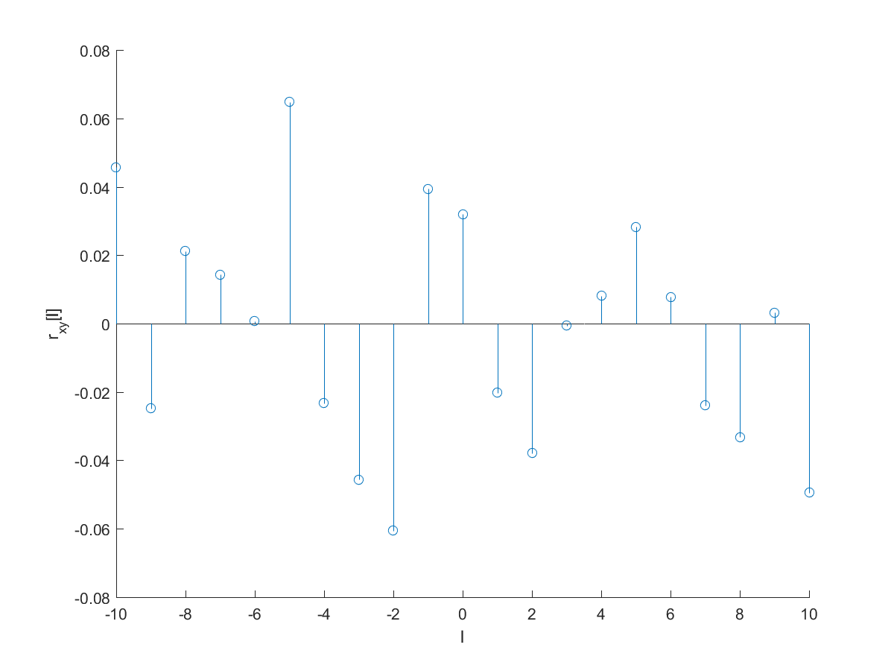

**Figure 8: cross-correlation test plot**

1. Which value of l produces the largest cross-correlation? Why?

No $l$ produces the largest cross-correlation. Both sequences ($x, z$) are not related, and does not show any correlation.

1. Is the cross-correlation function an even function? Why or why not?

No. From the figure it can already be seen that the results are not mirrored at $l = 0$. Secondly, an even function requires that $r_{xy}\left[l\right]=r_{xy}\left[-l\right]$ and thus $E\left\{x\left[n\right]y\left[n+l\right]\right\}=E\{x\left[n\right]y\left[n-l\right]\}$, which only may happen in periodic signals (or by coincidence).

**Assignment 26: Estimate delay for radar data**

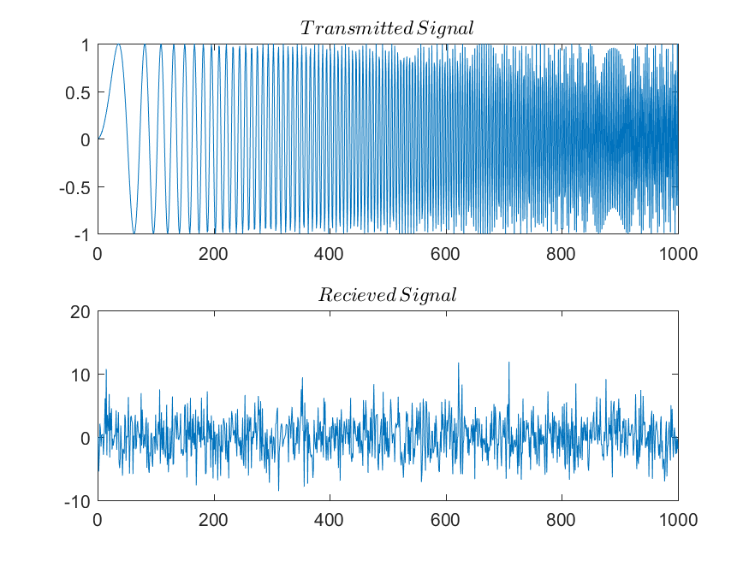

**Figure 9: transmitted and received signal**

b)

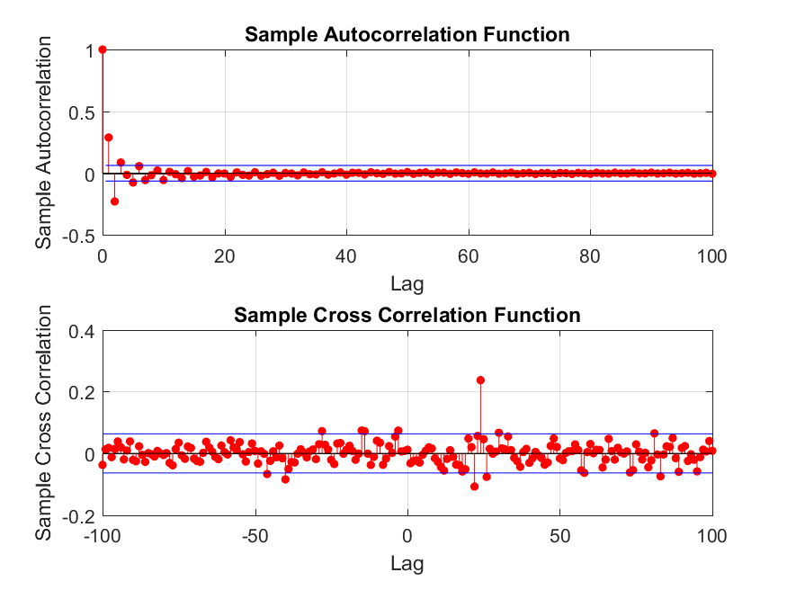

**Figure 10: auto- and cross-correlation**

1. Delay for :

The time delay $τ$ is most likely to occur at the largest auto correlation this is for $τ=24$  
Therefore the $τ$ equals 24

Bonus questions:

1. How would you reduce the influence of the noise w[n]?

By placing a white Gaussian noise filter, this results in a low pass filter and a high pass filter which will pass the desired transmitted signal and block the white Gaussian noise.

1. How would you handle non-integer values for τ?

By interpolating the values of succeeding samples and then taking a weighted average based on the distance between the samples and the non-integer value for $τ$.  
In this way the closer one integer sample is to non-integer value for $τ$ the higher influence this sample has to $τ$.